16 BIT SUBTRACTION

EXP NO: 6

AIM: To write an assembly language program to implement 16 bit subtraction using 8085 processor.

ALGORITHM

1. Start the program by loading the first data into the accumulator.
2. Move the data to a register.
3. Get the second data and load into the accumulator .
4. Add the two register content.
5. Check for carry.
6. Store the value of sum and carry in the memoty location.
7. Halt

PROGRAM:

LHLD 2500

XCHG

LHLD 2502

MVI C,00

MOV A,E

SUB L

STA 2054

MOV A,D

SUB H

STA 2055

HLT

INPUT:

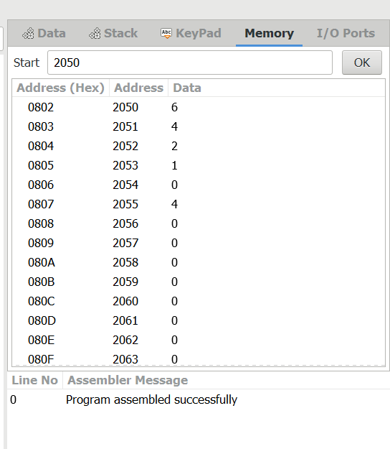

OUTPUT:

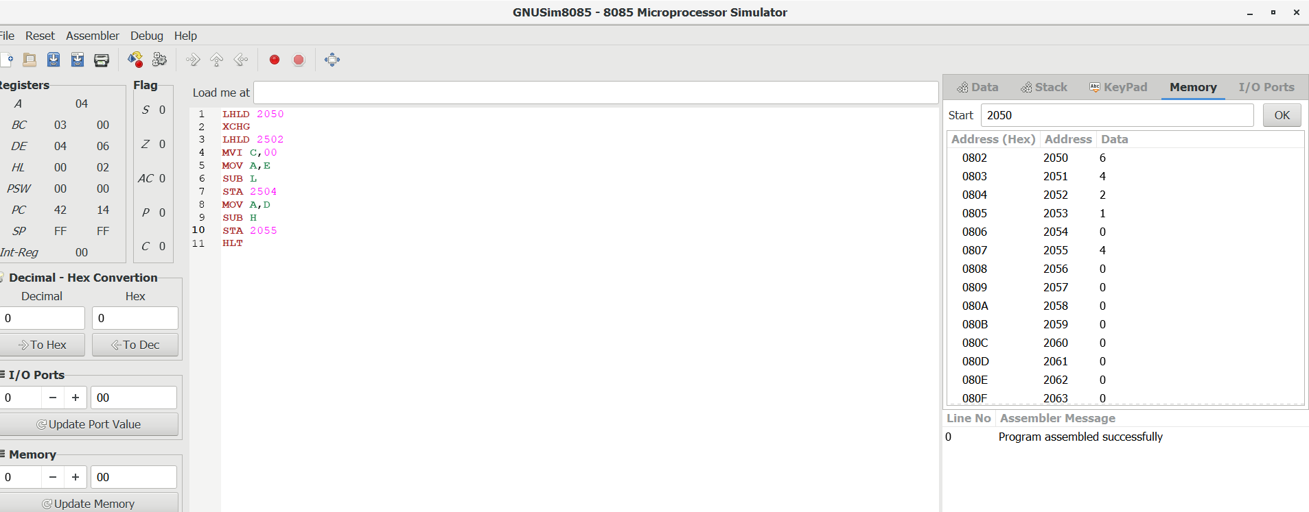

RESULT:

Thus the program was executed successfully using 8085 processor simulator.